COMSATS University Islamabad
Attock Campus


Department Of Computer Science

Course | Information Security
Instructor | Mam Ambreen Gul
Assignment No. | 03
Student Details

Registration No. | Name
FA24-BSE-017 | Mubashir Hussain

Task:01
Code:
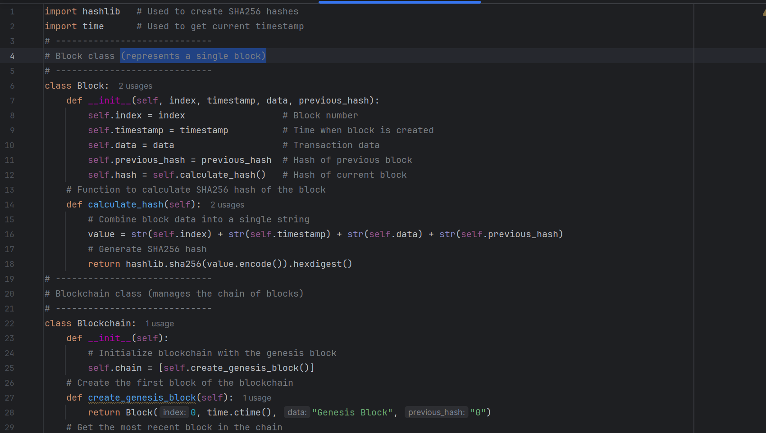

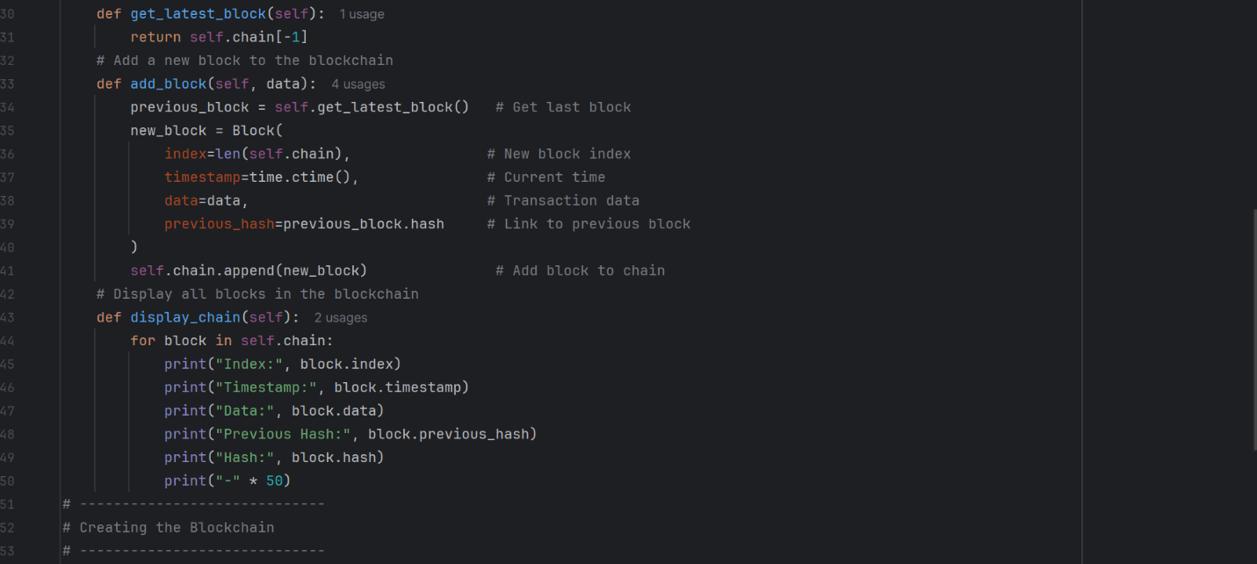

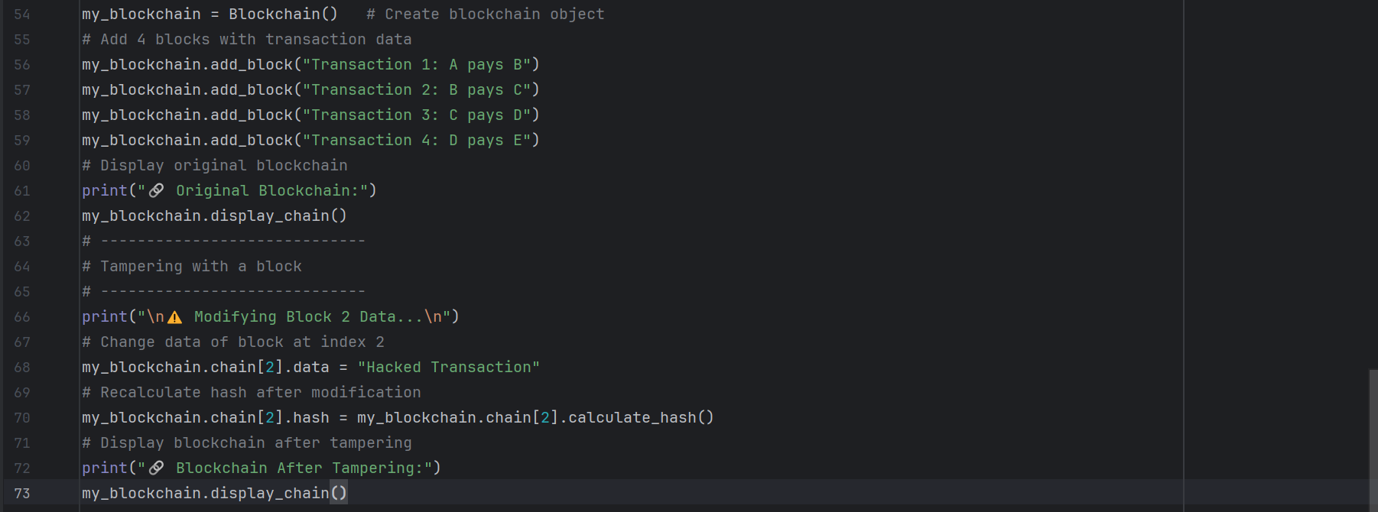

Code Explanation line by line:
import hashlib
Imports the hashlib library, which is used to generate SHA-256 cryptographic hashes.
import time
Imports the time module to generate timestamps for each block.
class Block:
Defines a Block class representing a single block in the blockchain.
__init__(self, index, timestamp, data, previous_hash)
Initializes a block with an index, timestamp, data, and the hash of the previous block.
self.hash = self.calculate_hash()
Automatically calculates the hash of the block to ensure data integrity.
calculate hash()
Combines all block attributes and generates a SHA-256 hash. Any change in block data results in a different hash.
class Blockchain:
Defines the Blockchain class that manages the list of blocks.
create_genesis_block()
Creates the first block of the blockchain, known as the Genesis Block.
add_block(data)
Adds a new block to the blockchain by linking it to the previous block using its hash.
display_chain()
Displays all blocks and their attributes, allowing us to observe the blockchain structure
Security Analysis
Blockchain security in this implementation is achieved through cryptographic hashing and block linking. SHA-256 hashing ensures data integrity, while linking blocks using previous hashes creates immutability. Any unauthorized modification is immediately detected. However, this implementation does not include encryption, consensus mechanisms, or peer-to-peer networking, which are present in real-world blockchains.

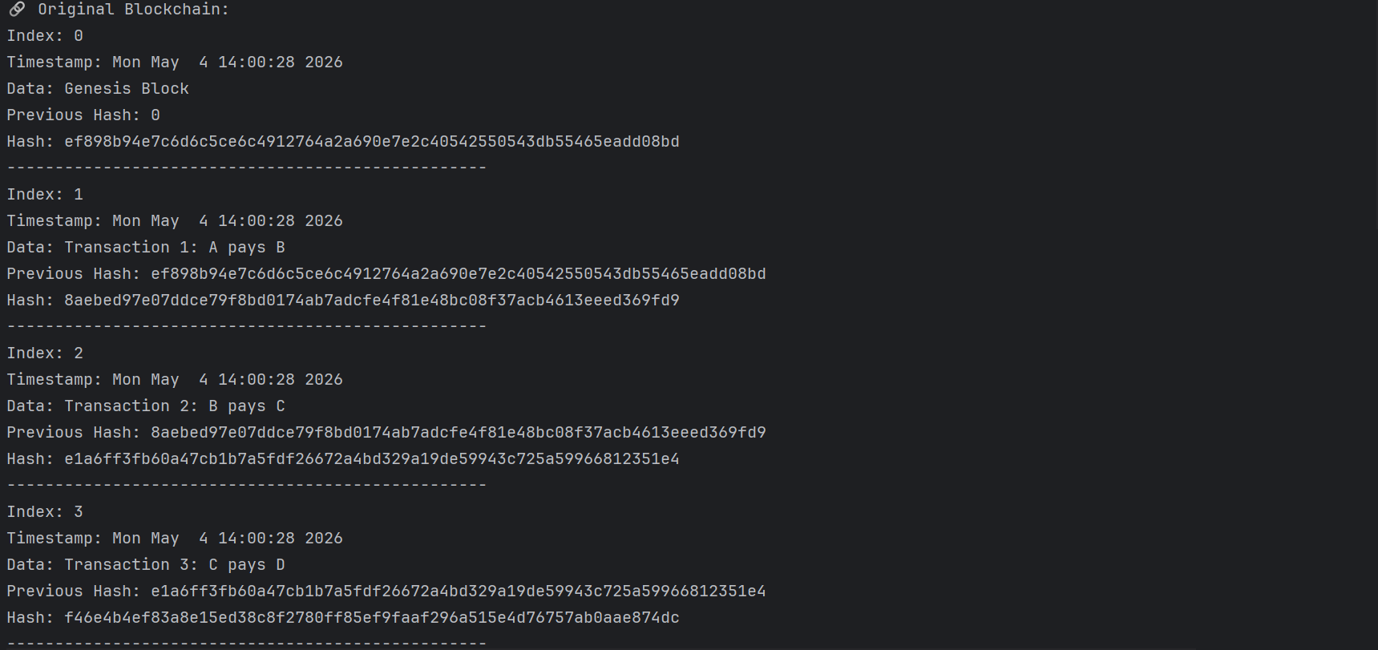
Output:

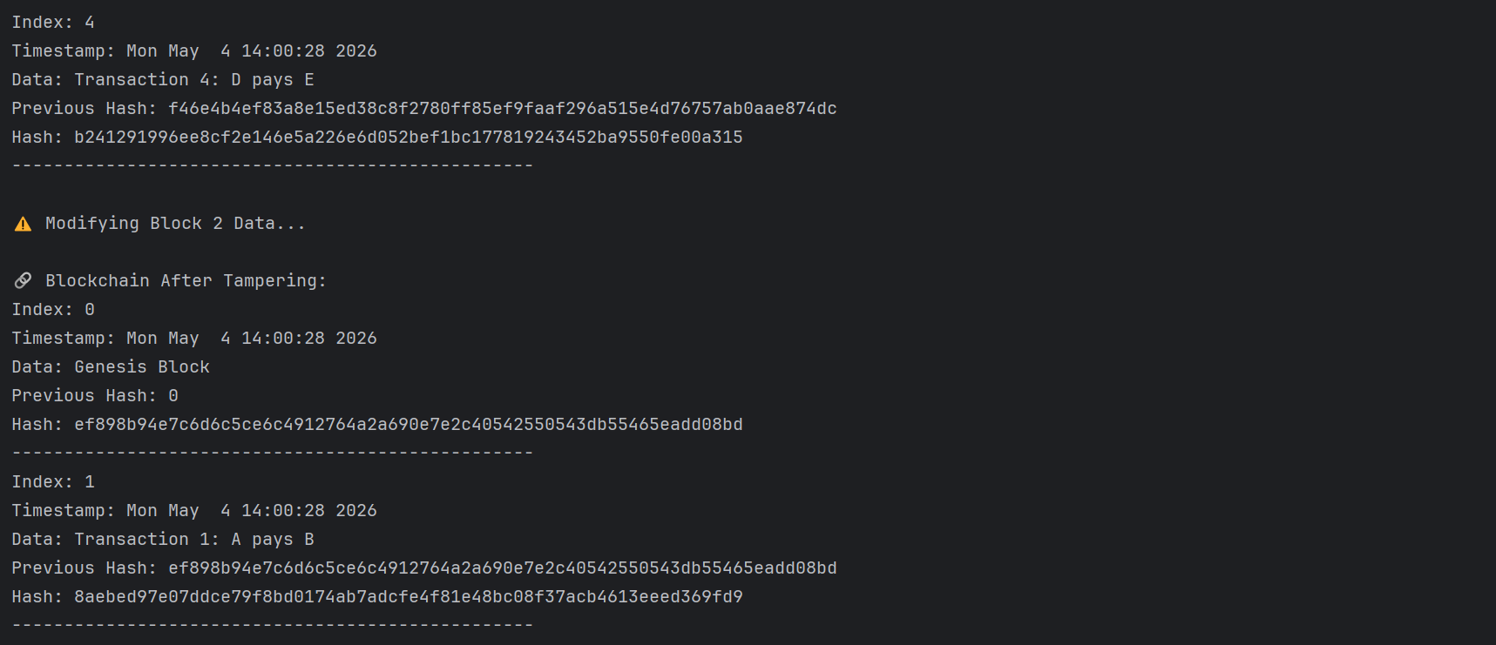

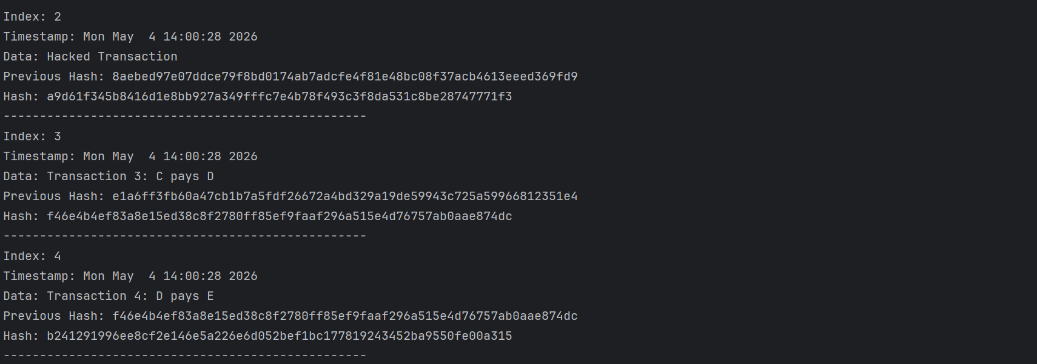

Task:02
Code:
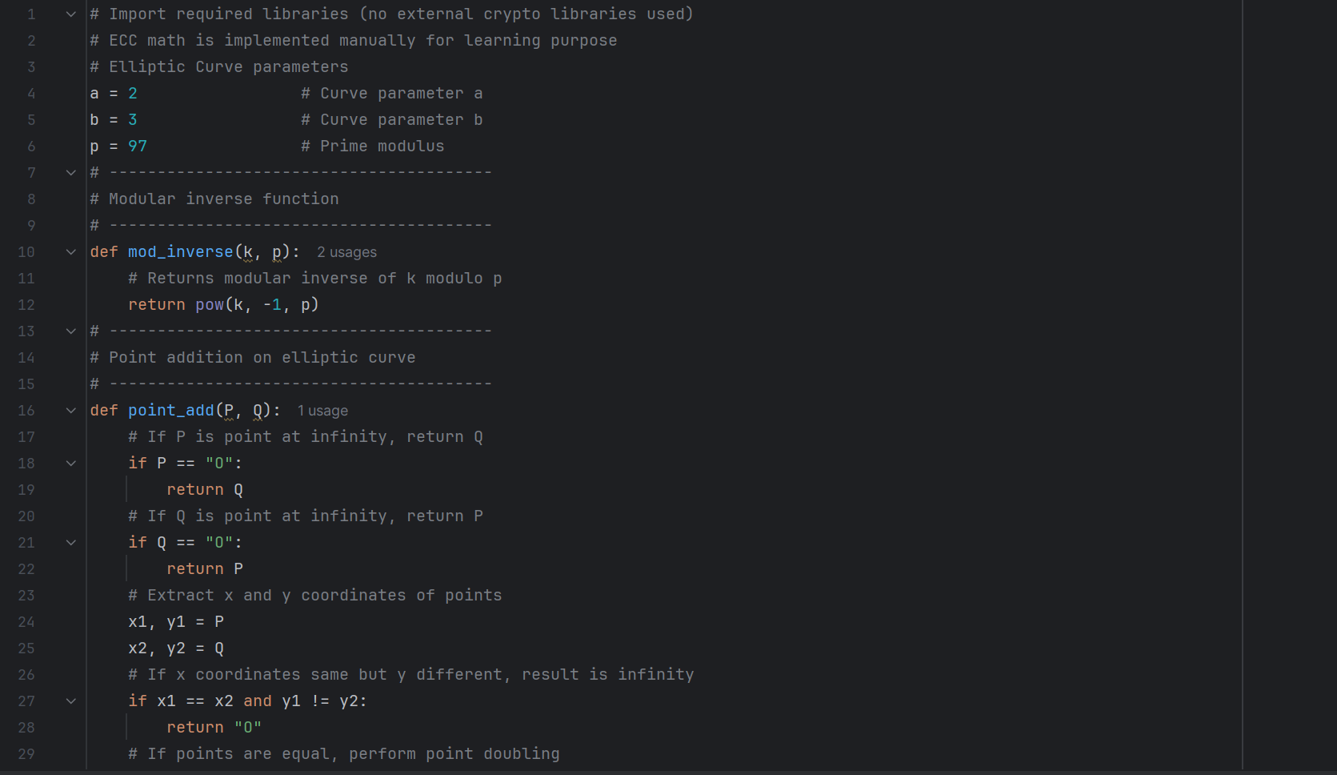

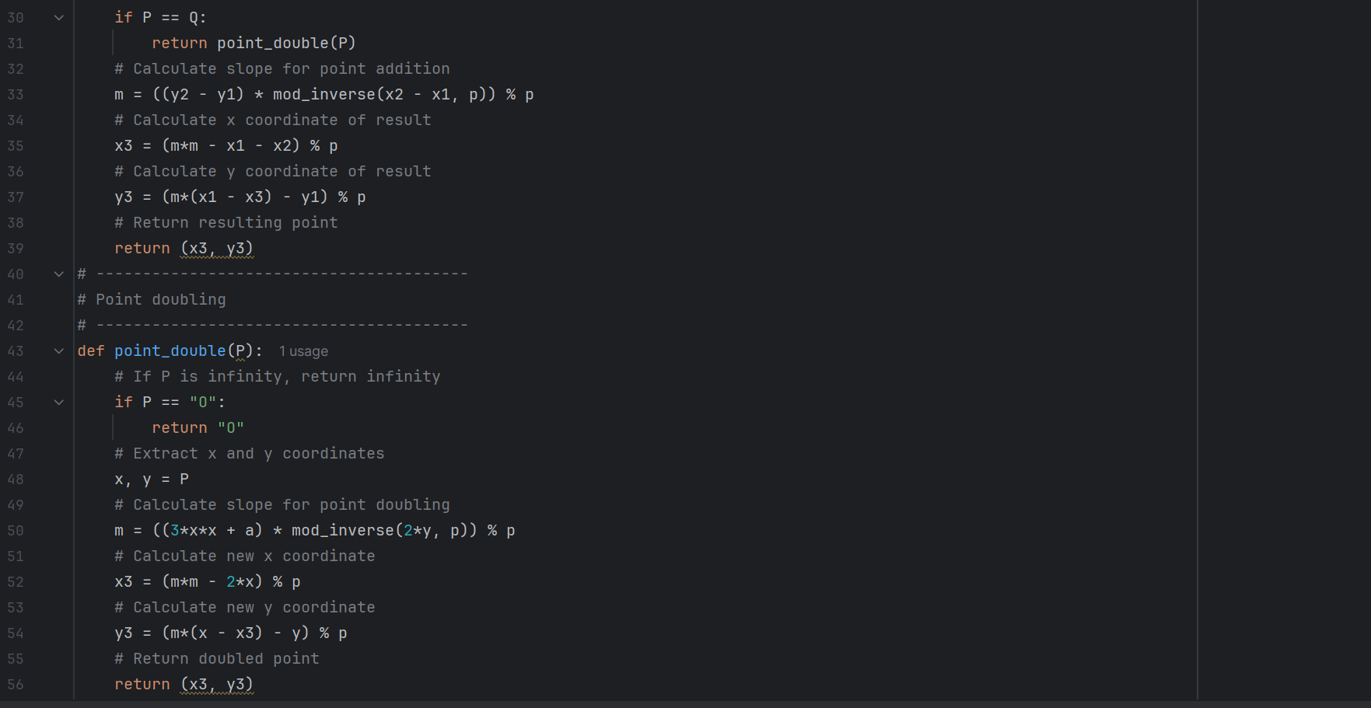

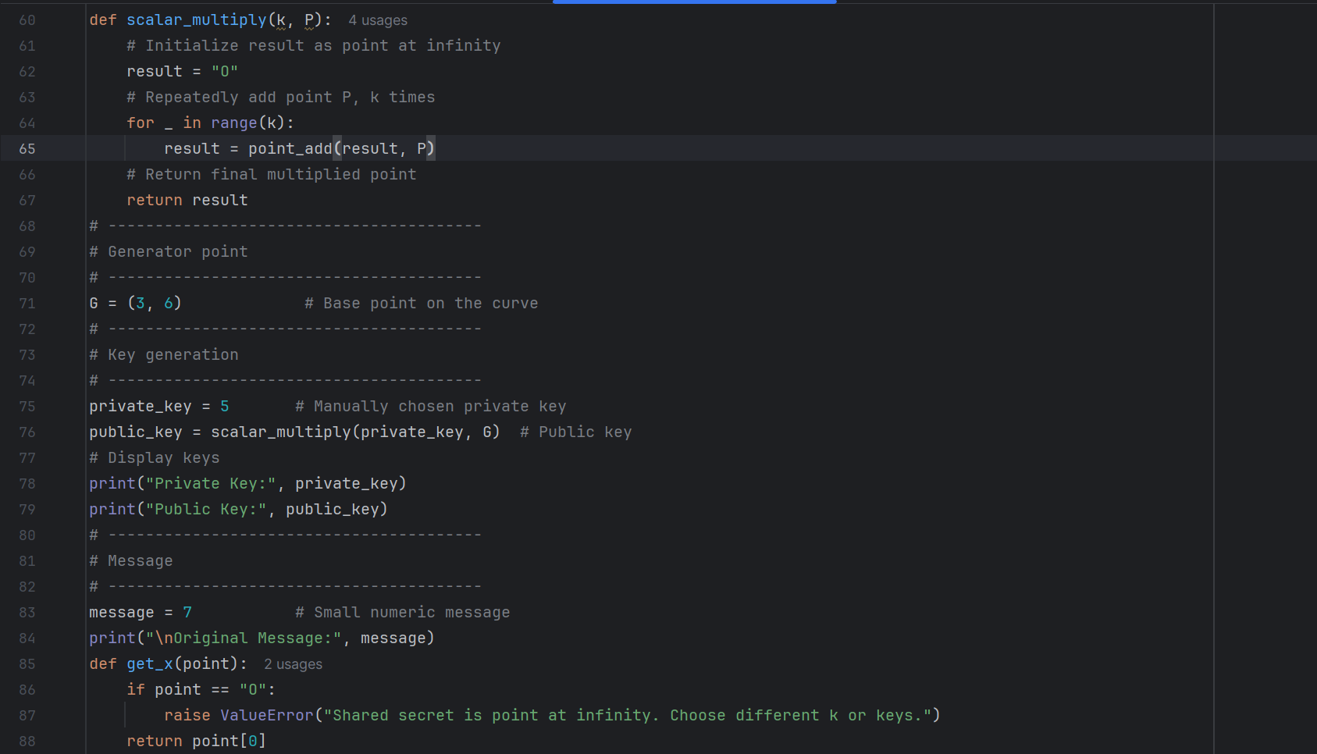

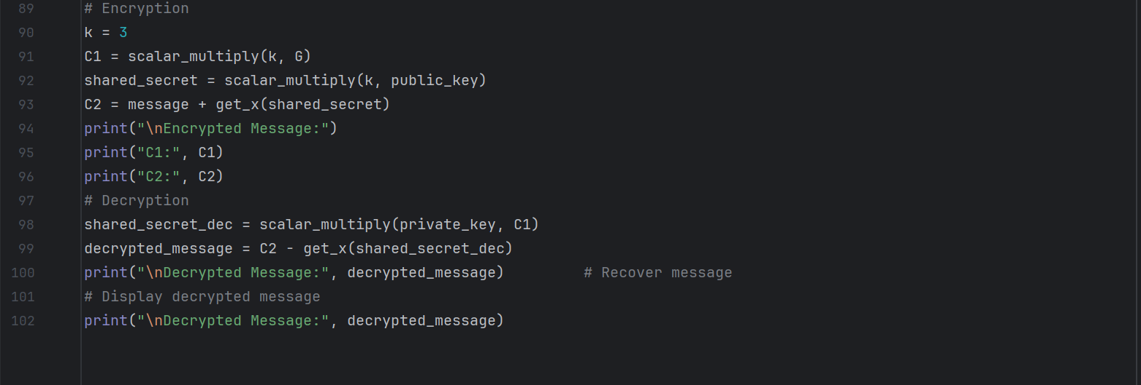

Code Explanation line by line:
- Overview:
The program demonstrates ECC key generation, encryption, and decryption using elliptic curve arithmetic over a finite field.
- Curve Parameters:
- a = 2, b = 3 define the elliptic curve equation y^2 = x^3 + ax + b mod p - p = 97 defines the finite field
- Modular Inverse:
Used to perform division in modular arithmetic using pow(k, -1, p).
- Point Operations:
- Point addition handles combining two points on the curve
- Point doubling handles adding a point to itself- Special case: "O" represents point at infinity
- Scalar Multiplication:
Repeated point addition used to compute kP.
- Key Generation:
- Private key is a secret integer
- Public key is computed as private_key * G
7. Encryption:
- Uses ephemeral key k
- Computes C1 = kG
- Shared secret = k * public_key
- C2 = message + x-coordinate(shared secret)
8. Decryption:
- Recomputes shared secret using private key- Recovers message by subtracting x-coordinate SECURITY ANALYSIS:
Strengths:
- Correct ECC mathematical structure
- Based on Elliptic Curve Discrete Logarithm Problem- Demonstrates secure key exchange concept
Weaknesses:
- Very small prime field (p = 97) makes brute force easy
- Scalar multiplication is inefficient (O(k))
- Ephemeral key k is not random
- No hashing or key derivation function
- No authentication or integrity protection
- Simplified encryption (message + x-coordinate)

Output:

